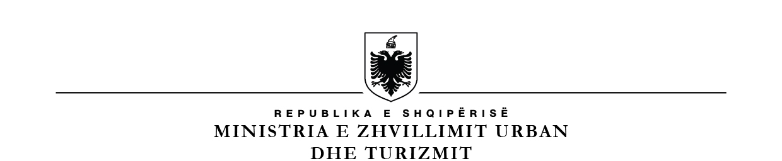

**BASHKIA VAU DEJES**

**KËSHILLI BASHKIAK VAU DEJES**

**Kryetaret e fshatrave Bashkia Vau Dejes**

**Njësia Administrative Vau Dejës**

|  |  |  |  |  |
| --- | --- | --- | --- | --- |
| **Nr.** | **Emri** | **Mbiemri** | **Fshati** | **Telefon** |
| 1 | Gjon | Preçi | Spathare | 0685644960 |
| 2 | Ndue | Nikolli | Gomsiqe | 0692132159 |
| 3 | Tonin | Rranxi | Kaçë | 0682613210 |
| 4 | Myftar | Babaj | Mjede | 0672845238 |
| 5 | Bik | Zefi | Shelqet | 0672826024 |
| 6 | Zef | Doda | Karmë | 0694622366 |
| 7 | Gjergj | Dodani | Naraç | 0682277060 |

**Njësia Administrative Bushat**

|  |  |  |  |  |
| --- | --- | --- | --- | --- |
| **Nr.** | **Emri** | **Mbiemri** | **Fshati** | **Telefon** |
| 1 | Zef | Jakaj | Rranxa | 0672849576 |
| 2 | Pjerin | Gjondrekaj | Konaj | 0672751329 |
| 3 | Basri | Zagani | Shkjeze | 0692474190 |
| 4 | Ndoc | Game | Plezhe | 0692658282 |
| 5 | Injac | Dedi | Ashte | 0692378592 |
| 6 | Gjeto | Makaj | Melgushe | 0673513322 |
| 7 | Simon | Dodaj | Bushat | 0694036430 |
| 8 | Frano | Dajani | Stajke | 0692885199 |
| 9 | Sabri | Kallami | Barbullush | 0683732552 |
| 10 | Ndue | Marku | Mali Jushit | 0682706289 |
| 11 | Kastriot | Duka | Fshati i Ri | 0672587279 |
| 12 | Mentor | Mlloja | Kosmaç | 0693435541 |
| 13 | Rrok | Gjerkaj | Hoten | 0694639699/0695857216 |
| 14 | Sokol | Lanazi | Kukel | 0672849851 |

**Njësia Administrative Hajmel**

|  |  |  |  |  |
| --- | --- | --- | --- | --- |
| Nr. | Emri | Mbiemri | Fshati | Telefon |
| 1 | Çesk | Brunga | Dheu I Lehte | 0674841246 |
| 2 | Albert | Dini | Paçram |  |
| 3 | Zef | Misuli | Nenshate | 0683178068 |
| 4 | Vlash | Dedaj | Pistull | 0692251687 |
| 5 | Tonin | Lukaj | Hajmel |  |

**Njësia Administrative Shllak**

|  |  |  |  |  |
| --- | --- | --- | --- | --- |
| **Nr.** | **Emri** | **Mbiemri** | **Fshati** | **Telefon** |
| 1 | Gjon | Kroni | Bene |  |
| 2 | Perk | Markushi | Palaj |  |
| 3 | Jak | Martini | Barcollë |  |
| 4 | Ndue | Pjetri | Vukjakaj |  |
| 5 |  |  |  |  |
| 6 | Hilë | Thepi | Vukaj |  |
| 7 | Nosh | Molla | Kroni I Madh |  |

**Njësia Administrative Temal**

|  |  |  |  |  |
| --- | --- | --- | --- | --- |
| **Nr.** | **Emeri** | **Mbiemri** | **Fshati** |  |
| 1 | Gjelosh | Guri | Kllogjen | 0685843901 |
| 2 | Lush | Kola | Malagji-Kajvall | 0699684775 |
| 3 | Gent | Marku | Kishe-Arre | 0685365464 |
| 4 | Ndoc | Shkambi | Qerret | 0693196420 |
| 5 | Tom | Marashi | Vilë | 0682972620 |
| 6 | Kol | Selimi | Koman | 0682374720 |
| 7 | Frederik | Gjoni | Gushtë |  |
| 8 | Zef | Mali | Toplane | 0698774435 |
| 9 | Zef | Qershija | Serme | 0686918422 |
| 10 | Pjetër | Zhuri | Telume | 0682324597 |

**Njësia Administrative Vig Mnele**

|  |  |  |  |  |
| --- | --- | --- | --- | --- |
| **Nr.** | **Emri** | **Mbiemri** | **Fshati** | **Telefon** |
| 1 |  |  | Mnele e Madhe |  |
| 2 | Prend | Gjetdoçaj | Mnele e Vogël |  |
| 3 |  |  | Vig |  |